“Improved Credit Card Fraud Detection with Deep Learning Algorithms”

Vivekrabinson  Department of Computer Science,  Kalasalingam Academy of Research and Education AnandNagar, Krishnankoil-626126, Tamil Nadu, India.vivekrabinson1993@gmail.com | N.R. Sudharsan  Department of Computer Science,  Kalasalingam Academy of Research and Education Anand Nagar, Krishnankoil-626126, Tamil Nadu, India.  nrsudharsan132004@gmail.com | Sri Dharshan S K  Department of Computer Science,  Kalasalingam Academy of Research and Education, Anand Nagar, Krishnankoil-626126, Tamil Nadu, India.  Spunkydharshan@gmail.com
Kishore D S
Department of Computer Science
Kalasalingam Academy of Research and Education, Anand Nagar, Krishnankoil-626126, Tamil Nadu,
kishoredsuresh1975@gmail.com

Abstract— Higher digital payment volume and escalating fraud patterns create obstacles for the financial industry when detecting credit card frauds. Machine learning approaches enable the sector to analyze buying patterns which enable identification of irregular conduct to establish detection accuracy. The study entity conducts model comparison through Multi-Layer Perceptron (MLP) Neural Network by using two pairings of classifiers that include XG Boost Classifier with Light GBM Classifier and Random Forest Classifier along with AdaBoost Classifier and Cat Boost Classifier. Previous data processing enables exploratory data analysis (EDA) to pull vital details from the datasets. The success rate of classification depends on two evaluation approaches that combine AUC-ROC scores and confusion matrices for performance assessment. The evaluated results show that the XG Boost and Multi-Layer Perceptron Neural Network method reaches an accuracy rate of 97.96% hence constituting an optimal system for detecting fraudulent transactions. Digital fraud systems obtain enhanced security through ensemble learning that works along with deep learning frameworks.
Keywords: Fraud; Random Forest Classifier; Anomaly Detection; Fraudulent Transactions; EDA; Feature Importance.
- INTRODUCTION
The rise of new companies worldwide, organizations are continuously striving to enhance their service quality to stay competitive. Achieving this goal requires processing vast amounts of data daily, originating from diverse sources and existing in various formats. This data often holds critical insights that shape the company’s future strategies. Consequently, businesses must not only store and process this information efficiently but also prioritize its security. Without proper protection, sensitive data can be accessed by unauthorized entities, leading to financial losses or even data breaches. Among the most targeted information is financial data, which, if compromised, can severely impact both individuals and businesses. Fraud exists in multiple forms, including check fraud, online sales scams, identity theft, charity fraud, debt elimination schemes, and insurance fraud. However, with the increasing adoption of cashless transactions, credit card fraud has become one of the most prevalent financial crimes. Credit card fraud occurs when unauthorized individuals use someone else's credit card information to make transactions without the cardholder’s consent. In recent research, fraudulent transactions involving credit cards globally resulted in financial losses amounting to approximately in billions. Although the volume of digital transactions has surged, the relative proportion of fraud cases has remained steady or even declined, thanks to the advancement of fraud detection systems. Despite these improvements, fraudsters continuously develop new

techniques to exploit security loopholes. Credit card fraud generally falls into two categories: physical card theft and the unauthorized acquisition of card details such as the card number, CVV code, and expiration date. Once fraudsters obtain this information, they can conduct unauthorized transactions, often going unnoticed until significant financial damage has occurred. To mitigate such risks, companies leverage various machine learning techniques to distinguish between legitimate and fraudulent transactions. the risk of credit card fraud has significantly increased. The attacks per an hour in day to day is been visualized in below picture.
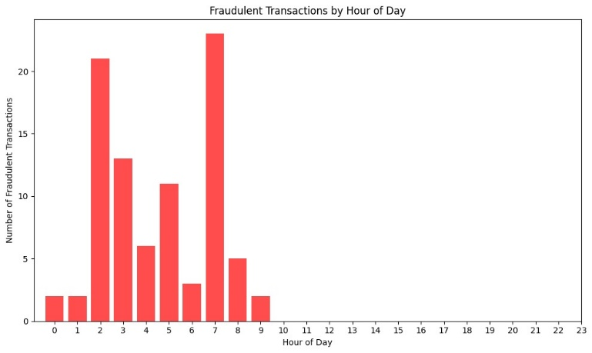 As online shopping becomes more Consumer choices now favor digital buying of products alongside services instead of traditional in-store purchases. More consumers choose to shop digitally because they avoid going to physical stores. This surge in e More openings for fraudulent actions emerged with the surge in e-commerce activity Online criminals seek to take advantage of weak points which appear in electronic transactions. To combat this, Identifying the best machine learning algorithm becomes vital for security purposes. The system uses an algorithm to both identify cases of credit card fraud and stop its occurrence. Secure and safer transactions require the implementation of this detection methodology.
- RELATED WORKS
The research paper [1] investigates how machines can detect credit card fraud. Researchers apply various learning techniques to develop systems that detect illegal payment transactions.
with high accuracy. With the rise of online transactions and e
Today e-commerce has developed into a major issue because of credit card fraud. This paper studies Random Forest and Ad boost algorithms through evaluation. The performance metrics consisting of accuracy together with precision and recall and F1-score are used for model comparison precision, recall, and F1-score. The Receiver Operating The assessment of models is possible through the graphical representation known as the Receiver Operating Characteristic (ROC) curve effectiveness. Both models demonstrated comparable performance results according to the findings. Better accuracy emerges from utilizing Random Forest instead of other approaches. The Random Forest model demonstrates superior accuracy as well as F1-score performance which makes it the more advantageous algorithm for fraud detection task. The research findings demonstrate that machine learning methods produce successful results as detectors of fraudulent activities. The detection of fraudulent activities can be achieved effectively yet more improvements are needed. Deep learning approaches hold potential to build up the detection system accuracy and adaptability regarding different fraud patterns. The models demonstrate capability to detect new fraud patterns in their environment. [2] This study investigates the effectiveness of various machine learning algorithms for the research demonstrates work on detecting credit card fraud as it deals with rising digital transaction risks digital transactions. The research implements the Credit Card Fraud Detection dataset.
The research team used Logistic Regression, Random Forest, Naïve Bayes, MLP on Detection dataset. RF, Naïve Bayes, NB, and Multilayer Perceptron. The MLP along with MLP and MLP serves as a method to distinguish transactions between fraudulent and genuine ones. Given the dataset's high imbalance, Synthetic Minority Oversampling Model performance gets improved through the application of Synthetic Minority Oversampling Technique (SMOTE). The conducted study demonstrates that Random Forest produces better results compared to the other methods. Random Forest demonstrates superior performance through its best achievement of accuracy and recall and precision for the given models. Random Forest stands as the most efficient detection method among all the algorithms tested for fraud detection purposes. The research document [3] demonstrates that combining feature selection along with data balancing methods improves fraud detection accuracy while calling for more studies about better model techniques. The investigation studies K-Nearest Neighbor (KNN) algorithm combination with outlier detection strategies for improving credit card fraud identification capabilities. Advanced techniques are necessary to detect fraud activities because of increased cashless transaction volumes. The investigation identifies machine learning and genetic programming and fuzzy logic techniques but KNN and outlier detection prove superior based on the authors' findings. Research has proven that these detection solutions provide valuable enhancements to the performance of fraud detection and at the same time reduce false error alerts. Financial security alongside fraudulent transaction reduction represent vital advantages that emerge when banking systems implement these methods based on the research outputs. The paper [4] evaluates combinations between ensemble learning strategies and classification algorithms for detecting credit card fraud anomalies inside unbalanced datasets. The scarcity of deceptive transactions makes it difficult for typical machine learning approaches to execute accurate detection methods. The research application evaluates five classification models - Logistic Regression with Support Vector Machines and Decision Trees and Random Forest and Gradient Boosted Trees which analyze data with oversampling and under sampling and SMOTE (Synthetic Minority Oversampling Technique) methods to balance result datasets. The analysis revealed Random Forest as the best fraud detection tool since it achieved a top recall value of 96%. The ensemble method of Stacked Classifiers demonstrates through evidence its ability to produce benefits through multidimensional combined models. Better fraud detection performance results from handling unequal data distribution alongside classifier optimization according to established research findings [5]. The research examines K-Nearest Neighbor (KNN) alongside outlier detection methods as they apply to credit card fraud detection. Credit card fraud poses an escalating threat to digital payments because people now heavily depend on digital payment methods. Traditional fraud detection methods struggle to distinguish fraudulent transactions from legitimate ones due to their sophisticated nature. The research evaluates various fraud detection techniques, emphasizing KNN-based classification and anomaly detection to improve accuracy. Due to their complicated nature modern fraud detection methods find it difficult to tell fraudulent transactions from legitimate ones. This research investigates multiple fraud detection methods keeping KNN-based classification and anomaly detection techniques at the center for achieving better accuracy levels. Research yielded findings which demonstrate that KNN successfully detects fraudulent transactions and controls false alarm rates to become a dependable fraud detection method. These financial systems achieve better fraud detection efficiency together with security through integrated implementation of these techniques.
- METHODOLOGY
The main purpose of this research work revolves around transaction classification. The dataset includes authentic as well as fraudulent transactions which must be classified in each instance transactions. The research makes use of deep learning techniques with MLP and four additional algorithms to reach its outcome more algorithms. A comparative analysis of these two models. The testing procedure evaluates the effectiveness between both solutions.
detecting fraudulent credit card transactions. The overall
The system develops methods for solving the credit card fraud detection issue. The procedure demands several sequential processes which include both data partitioning and model
The system follows steps that include training and then deploys models before evaluating their performance.
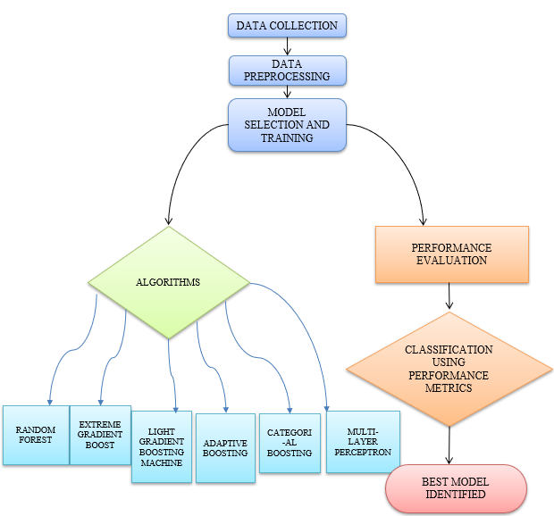
FIGURE 1 – WORKING OF METHODOLOGY

The architecture of the credit card fraud detection system, as
The FIGURE1 represents the multiple stages that comprise this process illustrated in [Figure 1]. Data collection serves as the entry point for the overall process which runs through multiple steps up to model deployment and final result analysis. The research employs the Kaggle credit card fraud dataset as its main source. A data refinement process takes place during preprocessing. To build the proposed system divides the dataset into sections for training and testing purposes. The developed Random Forest requires training data which gets used to train both the Random Forest model alongside additional models. The trained models proceed to for evaluation purposes. The evaluation metrics for performance assessment this process include accuracy and other metrics. precision, recall, and F1-score. Finally, a comparison is the researchers performed a test to identify which model exhibited better effectiveness in detecting fraudulent credit card transactions, model training, model deployment, and performance evaluation.
- Dataset
This research uses an available public Credit Card Fraud Detection Datum featuring PCA-transformed features V1–V28 along with Time and Amount data. The analysis covers two days of data containing 2lakhs+ transactions but only 500 entries among them represent fraud which leads to a 0.170% class imbalance. The analysis of transaction data shows that fraudulent activities produce separate and distinct variable patterns from legitimate activities. The model achieves better transaction distinction between real and fake items through a feature correlation analysis which determines the most important predictors. Cost-effective fraud detection requires focused attention on this issue since such massive imbalance affects accuracy and reliability performance.
- Data collection and preprocessing
The practice starts with obtaining relevant data while performing preprocessing to make sure the information meets training requirements. Data normalization and feature selection follow the handling of missing values as part of this step.
- Model selection and training
The gathered dataset enables multiple training sessions because different machine learning algorithms operate on it to create fraud detection models. The flowchart presents five important algorithms which will be discussed:
  - RANDOM FOREST
  - EXTREME GRADIENT BOOSTING (XGBOOST)
  - LIGHT GRADIENT BOOSTING MACHINE (LIGHTGBM)
  - ADAPTIVE BOOSTING
  - MULTI-LAYER PERCEPTRON (MLP)
  - CATEGORICAL BOOSTING

- Performance evaluation
The models are trained & their performance is tested to determine their efficiency in fraudulent detection.
- Classification using performance metrics
Metrics such as ACCURACY, PRECISION, RECALL are used to compare the models and effectiveness.

IV. EVALUATION AND RESULT ANALYSIS
This part explores the performance outcomes of Random Forest, XGBoost, Gradient Boosting, LightGBM and Multi-Layer Perceptron (MLP) models used to detect fraudulent credit card transactions. The assessment relies on accuracy and precision together with recall F1-score alongside ROC-AUC to provide an exhaustive evaluation of model success. Fraud detection being crucial requires placing special importance on precision and recall scores to avoid missing any suspicious transactions. The reliability and bias reduction of performance estimation requires Repeated K-Fold Cross-Validation through three distinct split combinations applied in a 5-fold approach. The procedure reduces unpredictable elements and provides stable assessment metrics. The analysis concludes the most efficient model through performance-based classification which qualifies it for future applicability. Multiple performance metrics enable this approach to deliver a balanced evaluation process which reveals both good points and drawbacks of models for separating fraudulent transactions.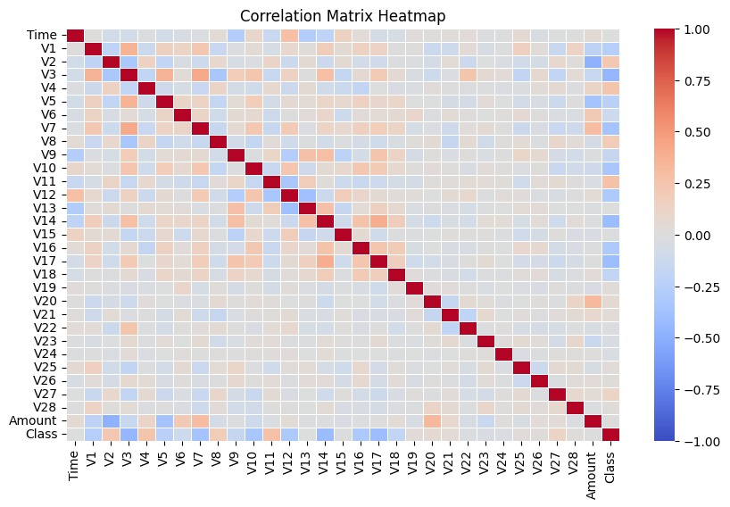
FIGURE 2-Correlation matrix heatmap of the datum
The FIGURE 2 represents a correlation matrix heatmap, illustrating the relationships between various features in a dataset. The diagonal elements are dark red, indicating perfect correlation (value of 1) since each variable is fully correlated with itself. The off-diagonal values show varying degrees of correlation, with colors ranging from red (positive correlation) to blue (negative correlation). The majority of correlations appear weak, as most cells are lightly shaded in neutral tones. However, some variables exhibit stronger positive or negative correlations, which could be important in identifying patterns, dependencies, or potential redundancies in the dataset. The presence of the "Class" variable suggests that this analysis may be related to classification tasks, such as fraud detection or anomaly detection in financial transactions.
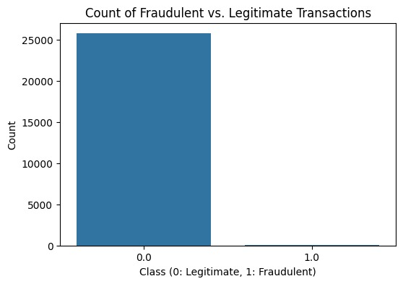
FIGURE 3 - “Imbalance in Credit Card Transactions: Fraudulent vs. Legitimate"
The FIGURE 3, bar chart shows how the dataset contains fraudulent and legitimate transaction occurrences. The bar graph shows transaction type on its x-axis while 0 stands for valid deals and 1 stands for fraudulent deals. This chart shows the transaction counts on the vertical axis. Results in the chart demonstrate that legitimate transactions outnumber fraudulent transactions by a wide margin thus illustrating severe class imbalance. The performance of machine learning models has the potential to suffer from class bias since minority class samples are much less common than majority class entries. The resolution of this data imbalance issue usually employs minority class oversampling together with majority class under sampling and specialized algorithms which effectively manage unbalanced data distribution.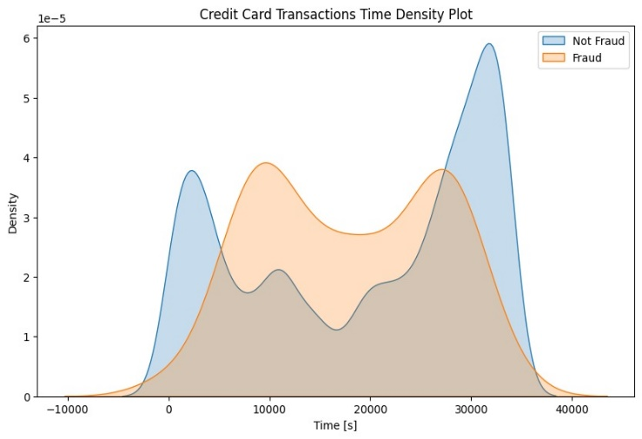
FIGURE 3- Transaction Evaluation using density plot
The time scale of seconds represents the x-axis and transaction density shows values on the y-axis. The plot displays two separate curves which respectively represent genuine transactions through blue color and fraudulent transactions through orange color. The overlapping regions indicate periods where both types of transactions occur at similar frequencies, while the peaks suggest time intervals where one class is more dominant. The plot reveals that fraudulent transactions follow a different distribution pattern compared to legitimate ones, occurring more frequently at certain time intervals. This insight is valuable for identifying time-based trends in fraud detection, allowing for the potential development of time-sensitive fraud prevention strategies.
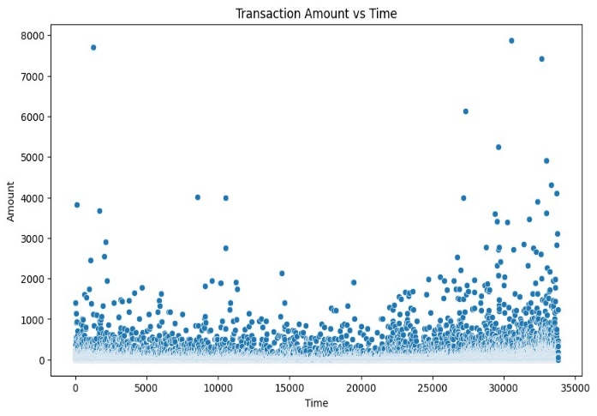
FIGURE 4-Transaction amount vs time using scatter plot
The FIGURE 4 scatter plot presents transaction amounts through time where time exists on the x-axis and transaction amounts appear on the y-axis. Most transactions occur within this area because the data points form tight clusters towards the lower edge of the amount range. However, there are several outliers where transaction amounts reach significantly higher values, with some exceeding 8000. Outliers appear randomly throughout the graph yet get more frequent near the right side that points to an emerging trend of growing transaction amounts. Such data distribution reveals possible irregularities that may help identify fraudulent activities and customer spending behaviors.
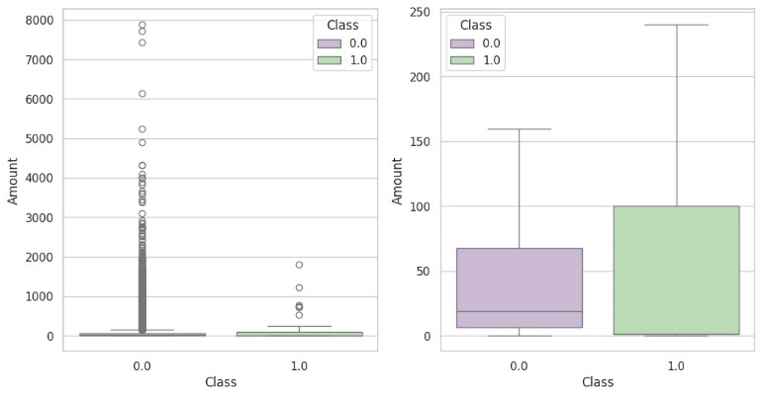
FIGURE 5-Analysis of boxplot examines the amounts in fraudulent and non-fraudulent transactions.
The Fig 5, presents two boxplots for transaction amounts which distinguish fraudulent (1.0) from non-fraudulent (0.0) transactions. The left graphic shows transaction data spanning from small to large values because non-fraudulent transactions contain outlier values above 7000. Fraudulent transactions have smaller transaction amounts that show limited occurrences of extreme values. When viewed on the right plot fraudulent transaction amounts take up a smaller scale which reveals they tend to reach higher median values than non-fraudulent transactions. The plot reveals fraudulent transactions stay tightly packed inside their specific range yet non-fraudulent transactions create a wide distribution pattern. The graphical representation indicates fraud detection researchers should include transaction amount information during the model-building process for anomaly detection systems.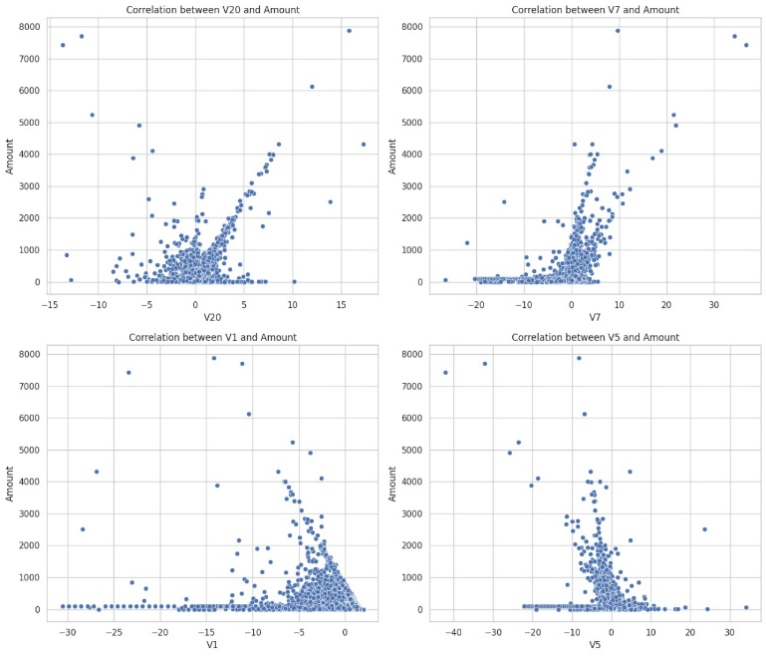
FIGURE 6-Correlation between features and the amounts
The FIGURE 6, contains four scatter plots analyzing the correlation between transaction amounts and four different variables (V20, V7, V1, and V5). Each plot visualizes how these variables interact with transaction amounts, potentially revealing patterns that could aid in fraud detection. Across all plots, most data points cluster near lower transaction values, with a few outliers exhibiting high amounts. In some cases, such as V7 and V20, there appears to be a noticeable trend where higher values of the variable correspond to higher transaction amounts. Meanwhile, V1 and V5 display a different pattern, where larger negative values appear to coincide with a decrease in transaction amounts. These insights suggest that certain variables may have stronger relationships with transaction values, which could be leveraged in predictive modeling for fraud detection. This analysis is valuable in financial research, helping to identify key factors influencing fraudulent and non-fraudulent transactions.
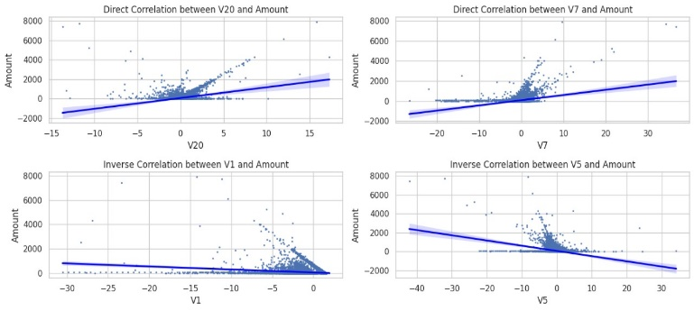FIGURE 7-Direct and inverse correlation of weighted feature
The FIGURE 7 presents four scatter plots illustrating the correlation between transaction amounts and the variables V20, V7, V1, and V5. Each plot is overlaid with a trend line, indicating the direction and strength of the correlation. The top two graphs depict a direct correlation, where V20 and V7 show a positive relationship with transaction amounts, suggesting that as these variables increase, transaction amounts tend to rise. In contrast, the bottom two plots highlight an inverse correlation, where V1 and V5 demonstrate a negative relationship, indicating that higher values of these variables correspond to lower transaction amounts. Financial fraud detection heavily relies on this analysis because researchers can use discovered relationships to create predictive models which separate legitimate from fraudulent transactions through the evaluation of essential variables.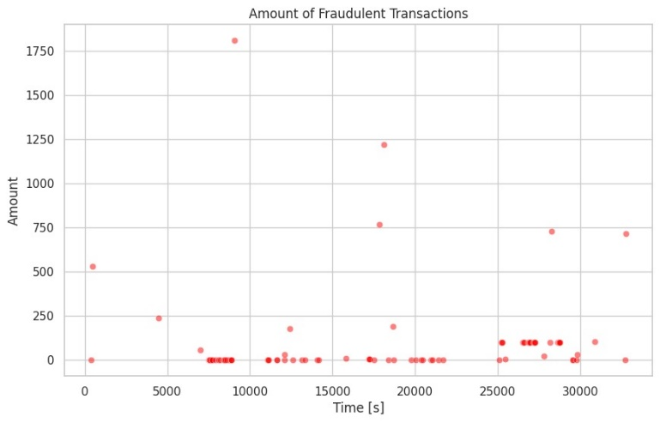
FIGURE 8-Fraudulent Transaction detected using the ml algorithm
The FIGURE 8, visualizes the distribution of fraudulent transactions over period of time, highlighting these amount associated with each instance. The data points, represented in red, show that fraudulent transactions occur sporadically throughout the given timeframe, with a majority of them involving smaller amounts. However, there are a few high-value fraudulent transactions dispersed at different time intervals. This pattern suggests that while most fraudulent transactions involve lower amounts, occasional large-scale fraud attempts exist. Such insights can be crucial in fraud detection strategies, as they indicate the necessity of monitoring both frequent low-value fraud and rare high-value anomalies for a comprehensive security approach. Notably, the application of a Random Forest model achieved a 96% accuracy in correctly evaluating fraudulent transactions, demonstrating its effectiveness in classifying between legitimate and fraudulent activities.
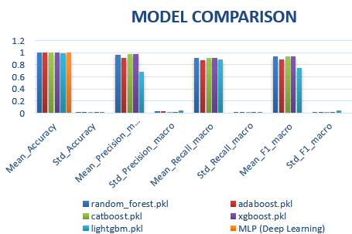FIGURE 9-Model comparison
The The analysis in FIGURE 9 displays a side-by-side evaluation of deep learning models used for fraud detection which incorporates Random Forest alongside CatBoost and LightGBM and AdaBoost and XGBoost and MLP (Deep Learning). The evaluation metrics encompass mean accuracy, standard accuracy, mean precision (macro), standard precision (macro), mean recall (macro), standard recall (macro), mean F1-score (macro), and standard F1-score (macro). Most of the evaluated machine learning models demonstrate high accuracy alongside precise forecasting capabilities yet they show variable differences in their recall and F1-score achievements. Notably, the Random Forest and ensemble-based models like XGBoost and LightGBM show consistent and reliable performance. Deep learning models especially MLP display inconsistent results because they tend to react to the distribution patterns in the data. The research by comparison gives essential understanding to select the optimal fraud detection model after evaluating its accuracy and robust performance metrics.
V.CONCLUSION
The evaluation of several classification algorithms on fraudulent transaction datasets yields significant information about model effectiveness. The results show that the Random Forest classifier performed quite well, with a recall of roughly 96%. This demonstrates its capacity to successfully identify fraudulent transactions even after training on a small dataset and testing on a highly imbalanced one. Despite its high recall, precision remained a difficulty, demanding additional enhancements to fraud detection systems. While Random Forest proved to be a strong classifier, ensemble learning techniques continually outperformed them. Gradient boosting improved model performance by iteratively refining decision trees and increasing predicted accuracy. Furthermore, under sampling approaches were crucial in correcting dataset imbalance, resulting in higher recall accuracy and less bias toward non-fraudulent transactions. The primary purpose of this research was to create an effective model for detecting fraudulent transactions with high accuracy. The findings support the usefulness of ensemble learning, particularly in addressing skewed datasets with few fraud cases. Future research should focus on further optimizing these strategies, including hybrid models that balance recall and precision for more reliable fraud detection in real-world scenarios.
Acknowledgment
All are like to express our heartfelt gratitude to everyone who contributed to the successful completion of this research. First and foremost, we extend our sincere thanks to our institution, KARE for provided the necessary resources and support. We are deeply grateful to our mentors for their invaluable guidance, and continuous encouragement throughout this research. Their expertise and support have been instrumental in shaping our work. Lastly, we acknowledge the contributions of researchers and experts in the domain of credit card fraud detection whose work has provided the foundation for our study.

References
- Credit Card Fraud Detection Using Machine Learning Proceedings of the International Conference on Intelligent Computing and Control Systems (ICICCS 2020) IEEE Xplore Part Number: CFP20K74-ART; ISBN: 978-1-7281-4876-2
- Varmedja, Dejan, et al. "Credit card fraud detection-machine learning methods." 2019 18th International Symposium Infoteh-Jahorina (Infoteh). IEEE, 2019.
- Malini, N., and M. Pushpa. "Analysis on credit card fraud identification techniques based on KNN and outlier detection." 2017 third international conference on advances in electrical, electronics, information, communication and bio-informatics (AEEICB). IEEE, 2017.
- Mishra A, Ghorpade C. Credit card fraud detection on the skewed data using various classification and ensemble techniques. In2018 IEEE International Students' Conference on Electrical, Electronics and Computer Science (SCEECS) 2018 Feb 24 (pp. 1-5). IEEE.
- Navamani, C., and S. Krishnan. "Credit card nearest neighbor-based outlier detection techniques." International Journal of Computer Techniques 5.2 (2018): 54-60.
- Saputra, Adi. "Fraud detection using machine learning in e-commerce." International Journal of Advanced Computer Science and Applications 10.9 (2019).
- Roy, Abhimanyu, et al. "Deep learning detecting fraud in credit card transactions." 2018 systems and information engineering design symposium (SIEDS). IEEE, 2018.
- Karkaba, I. M. A. N. E., E. M. Adnani, and M. Erritali. "Deep Learning Detecting Fraud in Credit Card Transactions." Journal of Theoretical and Applied Information Technology 101.9 (2023).
- Parmar, Darshna, and Tanaya Ganguly. "Analysis on Credit Card Fraud Identification based on KNN and Outlier Detection." (2020).
- Khodabakhshi, Masoud, and Mehdi Fartash. "Fraud detection in banking using knn (k-nearest neighbor) algorithm." International conf. on research in science and technology. 2016.
- Trivedi, Naresh Kumar, et al. "An efficient credit card fraud detection model based on machine learning methods." International Journal of Advanced Science and Technology 29.5 (2020): 3414-3424.
- Wang, Dehua, Yang Zhang, and Yi Zhao. "LightGBM: an effective miRNA classification method in breast cancer patients." Proceedings of the 2017 international conference on computational biology and bioinformatics. 2017.
- Shargunam, S., and G. Rajakumar. "An efficient glioma classification and grade detection using hybrid convolutional neural network-based SVM model." The Imaging Science Journal 72.1 (2024): 1-22.
- Khan, M. Adam, et al. "Machining parameter optimization using Adam–Gene Algorithm while turning lightweight composite using ceramic cutting tools." International Journal of Lightweight Materials and Manufacture 4.2 (2021): 262-267.
- Akash, C. Renga, et al. "Assessment of ridge regression-based machine learning model for the prediction of automotive sales based on the customer requirements." Interactions 245.1 (2024): 289.
- Vivekrabinson, K., et al. "Multi-Stroke Handwriting Character Recognition and Enhancing Proficiency with CNN: A Touch-Based Writing Approach." 2023 International Conference on Research Methodologies in Knowledge Management, Artificial Intelligence and Telecommunication Engineering (RMKMATE). IEEE, 2023.
- Sundareswaran, N., Sasirekha, S., Vijay, M., & Vivekrabinson, K. (2024, January). Supporting Smart Meter Context Management Using OWL Ontology and Hyperledger Fabric Blockchain. In International Conference on Mathematics and Computing (pp. 29-40). Singapore: Springer Nature Singapore.

